CSI7: A MODIFIED THREE-PHASE CURRENT-SOURCE INVERTER FOR MODULAR PHOTOVOLTAIC APPLICATIONS
ABSTRACT
This paper analyzes the performance of a gridtied, wide power range, transformerless, modified threephase current-source inverter (CSI), named CSI7. The CSI7 topology is here analyzed along with a suitable space vector modulation strategy able to attenuate the excitation of the output CL filter. The theoretical analysis and simple analytic expressions highlighted the performance and limitations of the topology when employed as a single-stage photovoltaic (PV) inverter, with a particular emphasis on injected grid current distortion and ground leakage current values. The inverter wide input range allows interfacing PV strings of different module count with a simple closed-loop control. The principle of operation and control is described; the viability of the CSI7 topology was assessed with simulations and extensive experiments on a full-size laboratory prototype.

BLOCK DIAGRAM FOR PROPOSED SYSTEM
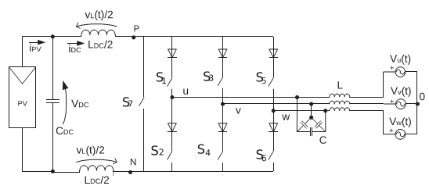
Fig. 1. Three-phase CSI7 topology.
DESIGNG SOFTWARE AND TOOLS:
MAT LAB /SIMULATION Software and simu power systems tools are used. Mainly control system tools, power electronics and electrical elements tools are used.

